**NAAN MUDHALVAN PROJECT REPORT**

**TITLE: INDIA’S AGRICULTURAL CROP PRODUCTION ANALYSIS**

1. **INTRODUCTION:**
   1. **OVERVIEW:**

Agriculture is an evolutionary process that consists of a series of activities such as

the production of foods, fibers, feed and raising of the domesticated animals to fulfill the demand of the population. India’s production of food grains has been increasing every year. In this project, we understand that overall agricultural crop production in India. India is among the top producers of several crops such as wheat, rice, pulses, sugarcane and cotton.

* 1. **PURPOSE:**

Agricultural is the foundation of the Indian economy. The population of India mostly depends on agricultural for their livelihood. It protect and enhance the environment and natural resources. Provide sufficient financial reward to the farmer to enable continued production and contribute to the well-being of the community. Provide sufficient high quality and safe food.

1. **PROBLEM DEFINITION AND DESIGN THINKING:**
   1. **EMPATHY MAP:**

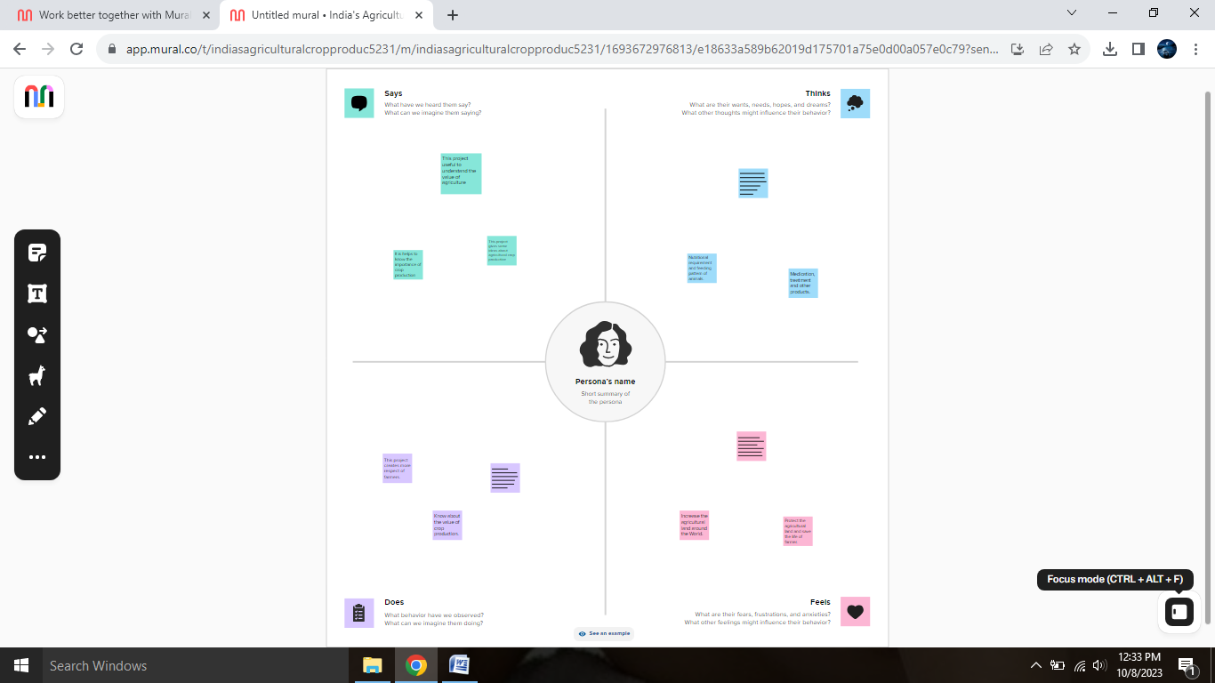

* 1. **IDEATION AND BRAINSTORMING MAP:**

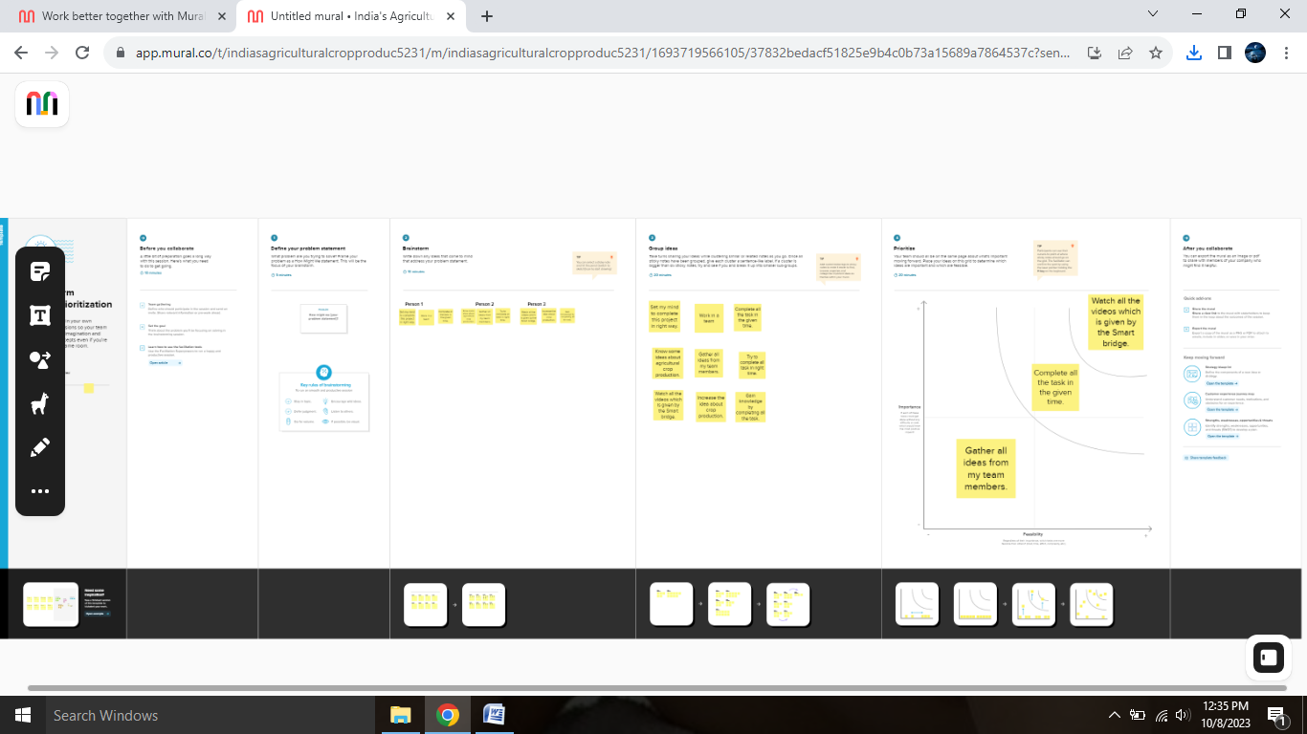

**3.RESULT:**

We find that top agricultural crop production state in India.

**DASHBOARD:**

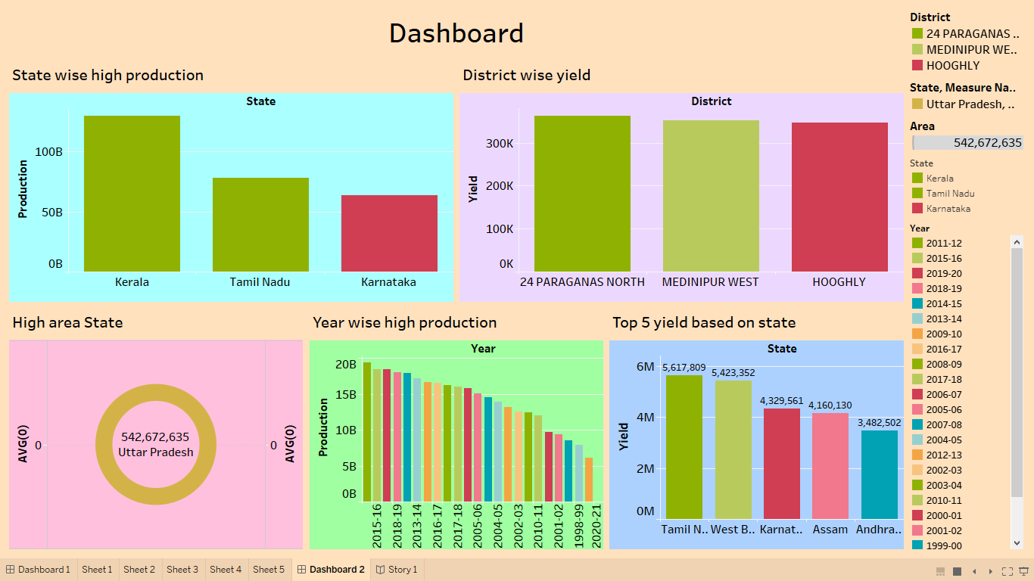

**STORY:**

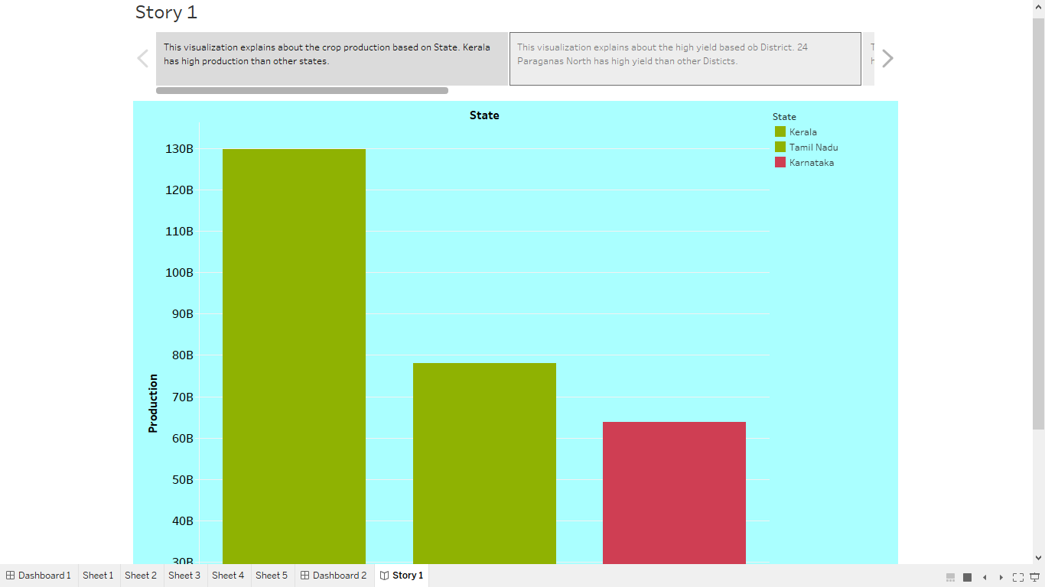

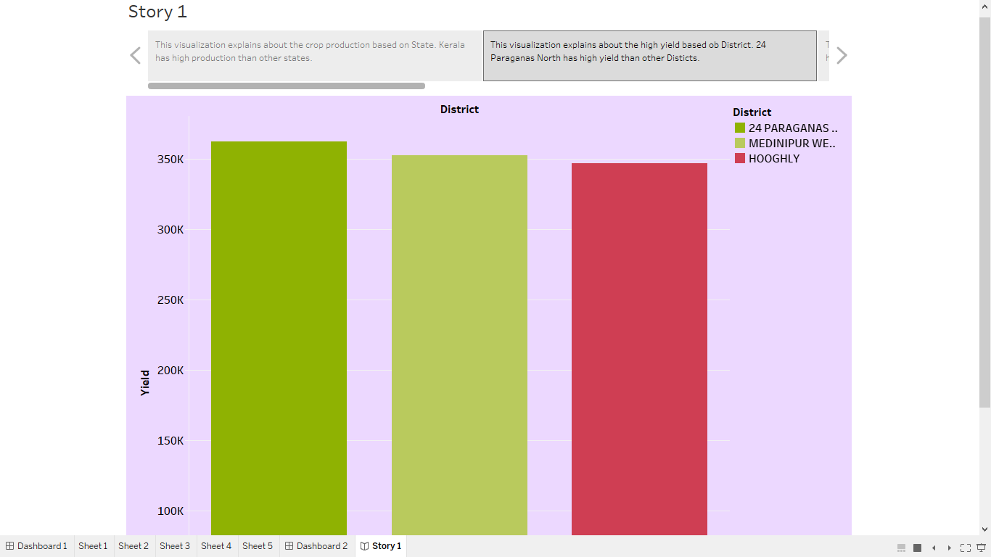

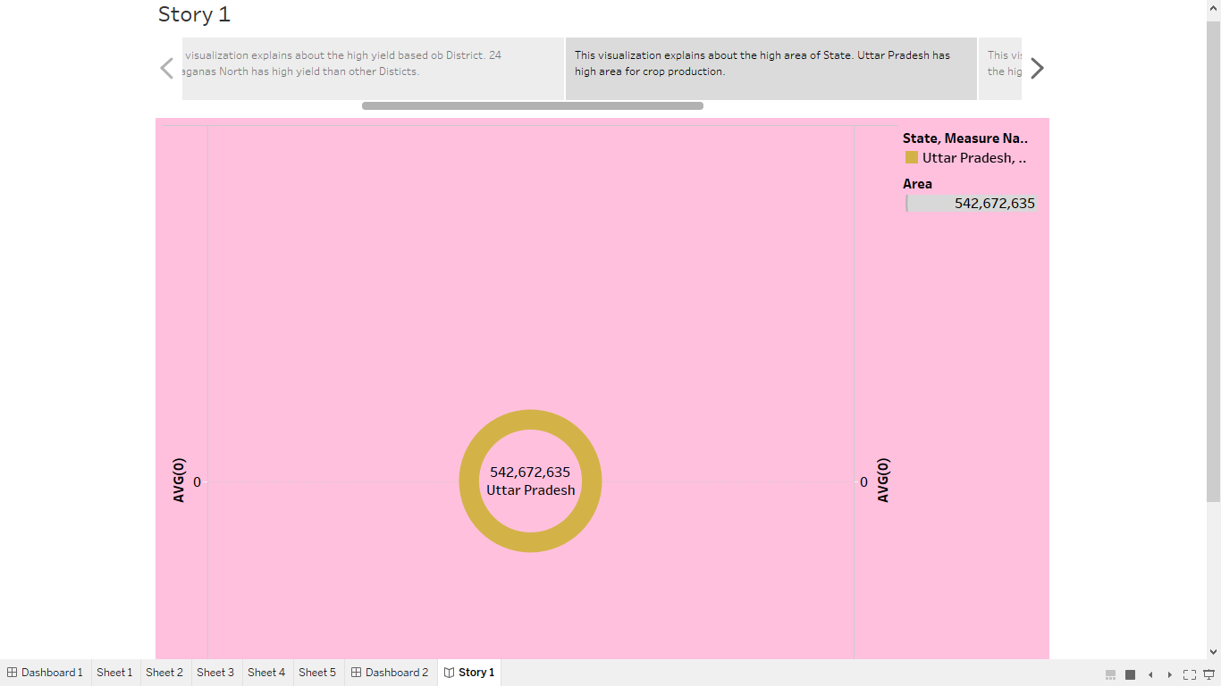

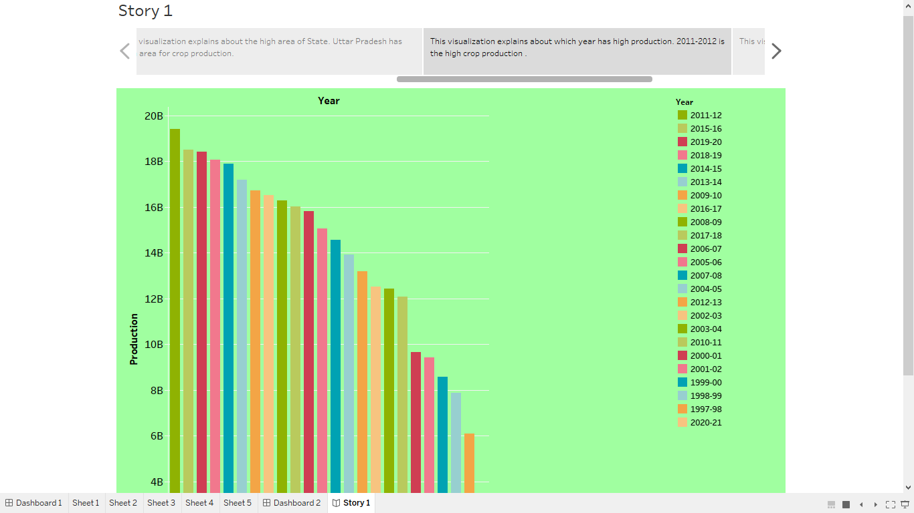

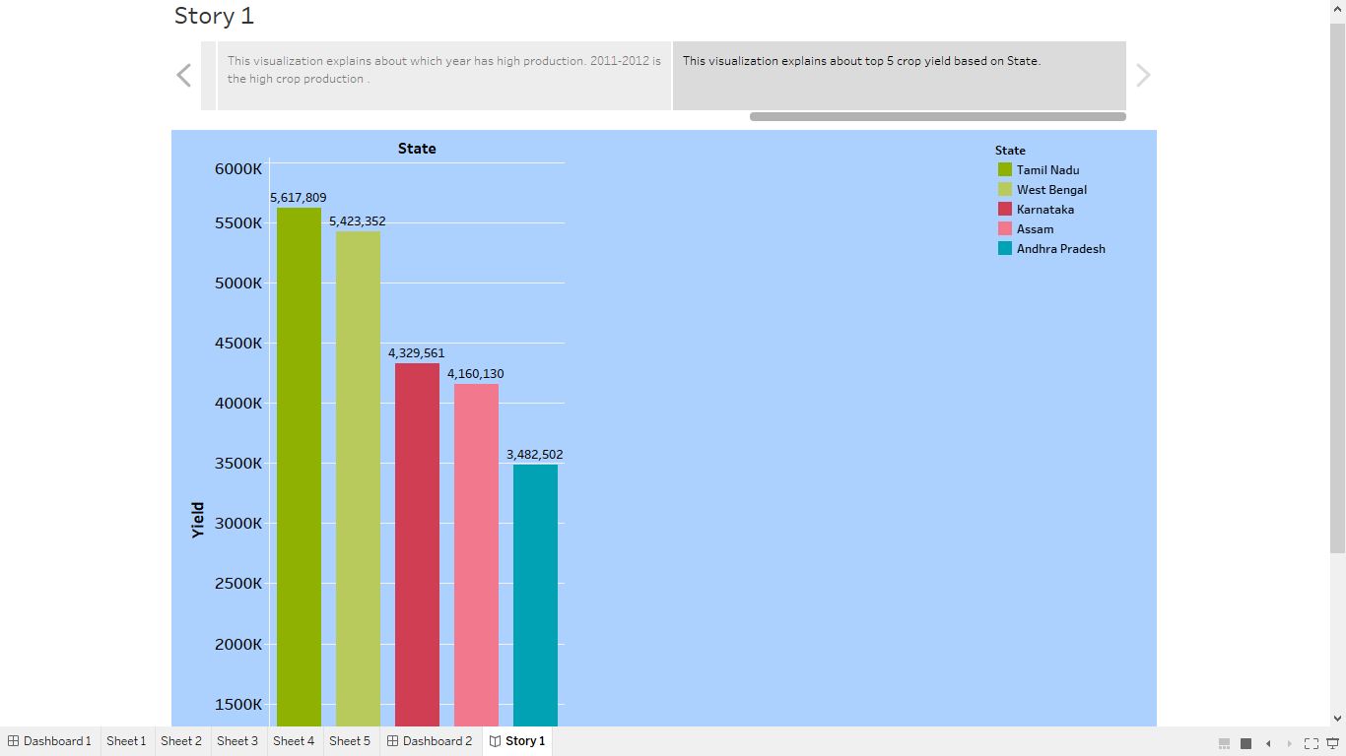

1. **ADVANTAGES AND DISADVANTAGES:**

**Advantages:**

1. There is over all increase in yield of crops mainly due to maintaining physical- chemical properties of soil. Soil fertility is restored by fixing atmospheric nitrogen, encouraging microbial activity (more organic matter) and protecting soil from erosion, salinity and acidity.

2. It helps in controlling insects, pests and soil borne diseases. It also controls weeds.

3. Prevent or limit periods of peak requirements of irrigation water.

4. It facilitates even distribution of labour. Following crop make proper utilization of all resources and inputs. Family and farm labour, power, equipment and machines are well employed thought the year.

5. Farmers get a better price for his produce due to higher demand in local market. So there is regular flow of income over year.

**Disadvantages:**

1. **Plantation agriculture is leading to deforestation:** Large areas of land must be removed from their natural vegetation to establish plantations, which can cause issues including soil erosion, ecological disruption, and biodiversity loss. Plantation farming is bad for the environment. Soil fertility is depleted and soil erosion is accelerated by overuse and lack of crop rotation. The majority of plantation estate owners live outside of the country, especially in the early stages of development, therefore they have little stake in the area's growth.

**2. Plantation agriculture leads to the multiplication of pests and diseases:** Plantation agriculture's use of monoculture may encourage the spread of pests and illnesses. Farmers that adopt monoculture on plantations lose soil fertility due to erosion and soil depletion. Due to the monoculture practiced on these plantations, pests and illnesses are more likely to spread.

3. **Decrease in the ground-level water:** Plantation agriculture can be water-intensive, leading to increased pressure on water resources, especially in regions already facing water scarcity. This can result in the depletion of groundwater levels and affect local communities' access to water.

**5. APPLICATION:**

Crop production is often concentrated in rural areas, and a strong agricultural sector can drive rural development. It provides employment opportunities, helps improve infrastructure (e.g., roads, storage facilities), and contributes to the overall quality of life in rural communities.  Many industries rely on crops as raw materials. For instance, the textile industry uses cotton, the bio-fuel industry uses crops like sugarcane and corn, and the pharmaceutical industry uses plants for medicinal purposes. A steady supply of these raw materials is crucial for industrial production.

**6. CONCLUSION:**

we can conclude that Crops are plants that are produced and harvested by farmers for profit or subsistence. Crops may be ingested by both animals and humans and are necessary for life to exist. The agricultural sector is of vital importance for the region. It is undergoing a process of transition to a market economy, with substantial changes in the social, legal, structural, productive and supply set-ups, as is the case with all other sectors of the economy.

**7. FUTURE SCOPE:**

Agriculture in India is livelihood for a majority of the population and can never be underestimated. Future of agriculture is a very important question for the planners and all other stakeholders. Government and other organizations are trying to address the key challenges of agriculture in India, including small holdings of farmers, primary and secondary processing, supply chain, infrastructure supporting the efficient use of resources and marketing, reducing intermediaries in the market. There is a need for work on cost-effective technologies with environmental protection and on conserving our natural resources. Along with this, the information technology revolution in India, new technologies in agriculture, private investments especially on research and development, government efforts to rejuvenate the cooperative movement to address the problems of small holdings and small produce etc are changing face of agriculture in India.